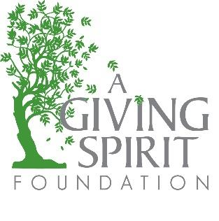
2023 Bourbon, Boots & Bubbles
Corporate Sponsorship Opportunities

Friday, February 3, 2023 @ 6:30pm
Sweet Magnolia Estate, Cornelius, NC

A Giving Spirit Foundation (AGSF) is a local 501c3 charitable organization formed in 2008 by a Davidson mother who had been diagnosed with ALS. She was grateful for the care, support and love she had received from her friends and family, but knew that other women in our community, who have been given devastating news, might not have the support system that she had. These women would need financial support to help pay for their rent, mortgage, utilities and medical bills.

AGSF was founded to allow these mothers to focus on their health and families rather than their mounting bills. Since inception, AGSF has provided local mothers with much needed relief from the financial stress and burden that comes with a debilitating disease.

AGSF is managed by an all volunteer board and we have no paid staff. We strive to keep overhead low and to put every available dollar to work for our beneficiaries. We rely solely on fundraising and the generosity of our loyal donors to provide for women in need.

We would love to introduce you to our organization and show you what it means to be A Giving Spirit. Please join us to celebrate the start of 2023 with a night under the twinkle lights. Enjoy dinner, drinks, and dancing, all for a good cause at AGSF’s Bourbon, Boots & Bubbles event which will be held Friday, February 3, 2023 at Sweet Magnolia Estate in Cornelius. This year, the event will feature two experiences – a bourbon tasting experience and champagne tasting experience. Our Platinum and Gold packages feature tickets to these experiences.

This is AGSF’s largest fundraising event of the year and offers marketing exposure to the Lake Norman and Charlotte community with a highly engaged, local audience.

Please contact Emily McGlon at emily.mcglon@gmail.com or Beth Phillips at bethbphillips@gmail.com to learn about our event sponsorship levels. Additional information on our organization and the fundraiser can be found on our website. https://www.agivingspiritfoundation.org.

Bourbon, Boots & Bubbles
Sponsorship Opportunities

The Platinum Package
$10,000 and above Includes:
Inclusion in all marketing for the event
Your logo on AGSF website
Signage at event
Exclusive sponsorship of one of our event experiences
2 Reserved Tables (16 Tickets)
AND, 16 Tickets to VIP Bourbon Tasting Or Bubble Lounge

The Gold Package
$2,500 Sponsorship Includes:
Inclusion in all marketing for the event
Your logo on AGSF website
Signage at event
Exclusive sponsorship of one of our event experiences
1 Reserved Table (8 Tickets)
PLUS, 8 Tickets to VIP Bourbon Tasting or Bubble Lounge

The Silver Package
$1,000 Sponsorship Includes:
Inclusion in all marketing for the event
Your logo on AGSF website
Signage at event
PLUS, 4 Tickets to the event

